
National University
of Computer & Emerging Sciences Peshawar Campus


Program: BS CS17-A&B
Semester: Spring-2020
Time Allowed: 3 hours
Course: Technical Business Writing(Code: SS141)
Examination: Final Exam
Total Marks: 105 Weightage: 50
Date: 24-06-20
Instructor Name: Ms. Maryam Ali Khan

Any plagiarized work will be rejected at once.

- Download the paper and solve it offline via conventional means of Pen and Paper. After solving the paper off-line, you are to submit the scan (taken through mobile cam or other necessary means) of solved paper in Pdf Format.
- The Pdf File (scan of solved paper) must be saved in the following form:
Name_RollNumber_CourseCode (e.g. Jehangir Khan_13P-6121_CS421)
- Solved paper is to be submitted within the finishing time as specified
- Late submissions will not be entertained.
- Solved paper must be sent via email on Maryam.khan@nu.edu.pk

Q.1: Write a letter to your director to share your feedback about the success or failure of online classes in Spring 2020. (Marks: 20)

Q.2: Represent the following data with the help of a Gantt Chart: (Marks: 20)

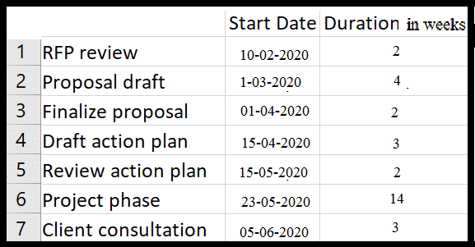

Q.3: Represent the rise and fall of the price of the following item with the help of a Line Chart: (Marks: 20)

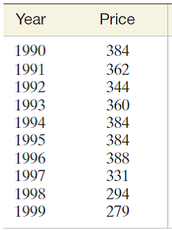

Q.4: One of your juniors asked you to teach him how to use Flex. Instruct him with the help of a Flow Chart. Your work must have at least two diamonds. (Marks: 15)

Q.5: Write a compare and contrast article on the topic “Life Before and After Covid-19”. The word limit for this article is 300-250 words. (Marks: 15)

Q.6: C.V plays an important role in shaping the future of a student. Keeping this in mind, it is important to have a well structured C.V. Compose a C.V to be ready for competing in the job market. (Marks: 15)

